How does Fed’s QE program affect foreign economies?

EC397

Kebing Li

**Introduction:**

In order to combat against the 2008-2009 financial crisis and the economic downturn afterwards, Fed had to employ unconventional monetary policy, as the conventional ones would not work in an environment where the interest rate hit the zero lower bound. Quantitative Easing, as one of the two major unconventional monetary policies Fed adopted during the financial crisis, was aiming at stimulating economy and increasing market liquidity by purchasing large-scale of long-term Treasuries and Agencies MBS/debt, and therefore the program is also known as LSAP (Large-Scale Asset Purchases). The four QE programs provided by the Fed involved replacing $4 trillion in highly liquid longer-term Treasury and agency securities held by the public with $4 trillion in highly liquid bank reserves at the Fed, and therefore, the programs helped with the duration of the supply of low-risk assets to the public and provided huge amount of liquidity to the market within 5 years, making QE the largest action done by any central bank in terms of direct asset purchases in the history. It seems that, from many aspects, the QE programs perform well domestically, which results in a decrease in the long-term interest rate and a more stable market condition. However, taking into account the size of the U.S. in the global economy and the massive scale of Fed’s intervention to the U.S. financial market, the QE programs likely also have induced huge impacts to the rest of the world. In this paper, I will be evaluating and presenting seven different papers addressing the relating topic.

**Spillover effects in general:**

Many effects on global markets during the post-crisis period could not be solely attributed to the QE programs, but in an environment of high capital mobility, a reduction in US interest rates required some combination of an appreciation of the foreign currency and a reduction in foreign interest rates. LSAPs, however, would somehow amplify the magnitude of the uncertainty of foreign currency and interest rates due to portfolio balance effects. Kuttner, in his paper discussing Quantitative Easing programs, explains, “Risky assets denominated in foreign currencies are substitutes for domestic risky assets. Therefore, in response to a QE-induced reduction in the supply of domestic risky assets, investors sl dollars and buy foreign currency in order to purchase foreign risky assets. This reduces the yields on foreign assets and puts pressure on the foreign currency to appreciate.” (Kuttner, 2017) Since lowering foreign bond yields are stimulative while foreign currency appreciation is contractionary, the net effect of QE on foreign economies is actually hard to tell. However, we can see from later reports that the effects can be both beneficial and hurting. Besides the foreign exchange market and bond market, financial data from several reports also shows that the prices of foreign stock markets are positively affected due to the huge capital outflow from U.S. to the EMEs, which can be either good or bad as well.

**Spillover effects on developed countries:**

As discussed above, the unconventional monetary policy would lead to an appreciation of the foreign currency and a decrease in the foreign bond yields. Christopher Neely, in his event-study paper *Unconventional Monetary Policy Had Large International Effects*, focuses on the 10-year nominal yields of developed economies like Australia, Canada, Germany, Japan, and the UK, and their exchange rates against the U.S dollars. He points out that the Fed’s unconventional monetary policy “substantially reduced international long-term bond yields and the spot value of the dollar even at the zero bound.” (Neely, 2010)

The depreciations of the US dollar during the “buy and sell” period ranged from 3.5 to 7.8 percent, shown by Table 1. We can see that among the developed economies the author investigated, euros were the most affected currency while the pounds were the least affected. The author says in his paper that “these responses are consistent with past estimates of equivalent conventional monetary policy shocks for EUR, GBP, and JPY” but the changes for “CAD and AUD are larger than would be expected”. (Neely, 2010) These observations suggest that QE programs behaved similar as conventional monetary policy with greater magnitudes to the developed economies.

The data presents by Table 2 captures the fact that international yields declined significantly after the implementation of QE. During the “buy and sell” period, nominal own-currency 10-year yield declined ranged from 63 bp for Australia to 18 bp for Japan. As the author points out later, “these expected excess bond yield declines are consistent with the predicted effect of such an asset purchase from a simple PB model that was estimated with historic data.” (Neely, 2010)

Overall, as Neely’s research shows, the spillover effects of Fed’s QE program on developed countries were mostly consistent with the predictions on currency and bond markets based on historic data except for some currencies which were affected more than expected, suggesting that the program in all didn’t put too much pressure on developed economies.

**Spillover effects on EME (Emerging Market Economies) and developing countries:**

The spillover effects driven by Fed’s QE programs raised, however, a lot concerns to the EMEs and developing countries. Due to the high reliance on exports and the preponderance dollar-denominated liabilities, a given percentage increase in the exchange rates of the EMEs is more detrimental to their economies than the same sized increase in the advanced economies’ exchange rates would be for the advanced economies. As President Rousseff of Brazil once described in 2012, Quantitative Easing would lead to a “monetary tsunami” and a “currency war.” Although these terms might be exaggerating because of political reasons, in order to control their currencies’ appreciation during the QE, many EME central banks indeed had to deliberately intervene in the foreign exchange market, which led to three problems: too much spending on holding foreign exchange reserves, more rapid growth in bank lending, and difficulty to control short-term interest rate when the reserve is saturated. (Kuttner, 2017) Also, searching for alternative investments options, investors shifted from the U.S. to EMEs, moving huge amount of capital to the emerging market countries, which led to the decrease of foreign bond yields and increase in asset prices due to the increase of demands. On a macro-level, EMEs, therefore, had to face the problem of having a price bubble and rise in expected inflation.

As an unprecedented macroeconomic and monetary “experiment” in terms of size and impacts, many studies have been conducted trying to understand the spillover effects of the Quantitative Easing program on the EMEs.

In David Bowman et al’s paper, *U.S. Unconventional Monetary Policy and Transmission to Emerging Market Economies*, the authors find that “EME asset prices, especially sovereign yields in local currency, experienced large fluctuations around unconventional monetary policy announcements by the Fed.” (Bowman, 2014) In particular, the sovereign yields decreased, the exchange rates rose, and the stock prices increased around each LSAP announcement. By separating the effects of each wave of LSAP, they also find from Figure 1 that the impact of different waves of LSAP announcement differed significantly, with the first LSAP significantly reducing the EME sovereign bond yields, increasing the exchange rates and foreign stock prices while other LSAPs demonstrating undistinguishable effects on sovereign bond yields and only moderate effects on exchange rates and stock prices.

In another paper, Fratzscher et al, provide a perspective from ECB (European Central Bank) and pay more attention to the effects on asset prices and capital flows. The authors of the paper “illustrate how US unconventional measures have contributed to portfolio reallocation as well as a re-pricing of risk in global financial markets.” (Fratzscher, 2013) They primarily focus on the data on portfolios flows including 16,000 equity and 8,000 bond funds in order to measure the size of the capital flows driven by Fed’s QE programs. Figure 2 compares the equity portfolio flows to emerging markets and to advanced economies. The trend highlights a potential positive consequence of the QE on EMEs.

Based on their empirical model on measuring the magnitude of flow changes, the authors in this paper also agree on the significance of QE1 relative to the other three, saying that the first LSAP triggered a substantial rebalancing in global portfolios, which led to lower bond yields and boosted equity market, and they point out based on their data on flows, QE2 actually induced a portfolio rebalancing in the opposite direction, moving more capital into EME financial markets. One other important finding the authors discuss in their paper is that their data indicates Fed policies influenced more on asset prices than the capital flows and played more like a magnifying mechanism to exacerbate both capital outflows and inflows.

Aizenman *et al* investigates an interesting topic on evaluating the impact of tapering “news” announcements by Fed senior policy makers on financial markets in emerging economies. What they find is that the emerging market asset prices responded the most to statements given by Fed’s chair Ben Bernanke, which is not a surprising result. However, by grouping emerging markets into “robust” and “fragile” fundamentals in terms of their financial health, they find the exchange rates and CDS spreads of the “robust” group were more adversely affected by the tapering news in short term. Furthermore, they also find that more financially developed countries were more impacted by the tapering news than less financially developed countries, and they interpret this phenomenon by hypothesizing “the more financially developed economies are more exposed, at least in short-term, to external news announcements.” (Aizenman, 2014)

Bhattarai, Chatterjee, and Park implements a more quantitative approach to estimate the effects of Quantitative Easing program on Emerging Market Economies, in which they use a monthly Bayesian panel VAR model to infer the spillover effects on these emerging market countries. Figure 3 shows the impulse responses of the panel VAR on EMEs. They point out that on average the EME currencies appreciated around 25 bp against the US dollar and the long-term bond yields decreased about 3 bp due to the expansionary QE shock. Also, the figure shows that QE program had a positive impact on the foreign stock markets around 100 bp and induced an increase around 2% of capital inflows to these countries.

Furthermore, this study shows that the “Fragile Five”, which includes Turkey, Brazil, India, Indonesia, and South Africa, were affected significantly greater than the other emerging market economies by the Quantitative Easing Program from Figure 4, proving the that these five countries were indeed highly dependent on unreliable foreign investment to finance their own growths.

Guillermo Ortiz, the chairman of the Bank of Mexico, discusses his view towards the QE program from an emerging market policymaker perspective. He points out that the Quantitative Easing program could be both beneficial and detrimental to the emerging markets. On one hand, the easy global monetary conditions coupled with a strong economic performance in developing countries stimulated a large flow of capital from advanced economies to emerging markets, and the huge capital inflows can be beneficial if they were supportive of investment and economic growth, meaning that more growth opportunities were provided to the emerging market economies. However, on the other hand, policymakers had to be worried about the fact that “market failures or inadequate regulation could lead to unsustainable increases in the price of assets, an overly generous provision of credit and lax standards.” Also, another issue that policymakers in EMEs had to face was a potential burst of the price bubble. As Ortiz described, “the most pressing questions for policymakers are how far will risk premiums rise before they stabilize and how can they smooth the adjustment. ” (Ortiz, 2016)

**Conclusions:**

Fed’s QE program has been viewed as a successful unconventional monetary policy in response to the financial crisis and it has significantly boosted the U.S. economy and rebuilt the market confidence. However, the oversea spillover effects of the policy were also significant. Although QE programs didn’t seem to have large impacts on the developed economies, developing economies or EMEs were significantly affected by the economic turbulences in terms of exchange rates, interest rates and asset prices. The overall effects to EMEs are still unknown even looking back from now, but it is definitive to say that EMEs have been experiencing a much more pressured period than the advanced economies.

References

Bhattarai, Saroj, Arpita Chatterjee, and Woong Yong Park (2018). "Effects of US Quantitative Easing on Emerging Market Economies." *SSRN Electronic Journal*, 2018. doi:10.2139/ssrn.3140100.

Bowman, David, Juan M. Londono, and Horacio Sapriza (2014). "U.S. Unconventional Monetary Policy and Transmission to Emerging Market Economies." *SSRN Electronic Journal*, 2014. doi:10.2139/ssrn.2459530.

Chibba, Michael (2008). "Monetary Policy for Small Emerging Market Economies: The Way Forward." *Macroeconomics and Finance in Emerging Market Economies* 1, no. 2 (2008): 299-306. doi:10.1080/17520840802252894.

Duca, Marco Lo, Giulio Nicoletti, and Ariadna Vidal Martínez (2015). "Global Corporate Bond Issuance: What Role for US Quantitative Easing?" *Journal of International Money and Finance* 60 (2016): 114-50. doi:10.1016/j.jimonfin.2015.07.013.

Fratzscher, Lo Duca, and Straub (2013). "On the International Spillovers of US Quantitative Easing" *ECB Working Paper Series* https://www.ecb.europa.eu/pub/pdf/scpwps/ecbwp1557.pdf

Kuttner (2017). "Has Quantitative Easing Earned a Place in the Fed’s Toolbox?" *Preliminary Paper* https://moodle.colby.edu/pluginfile.php/281696/mod_resource/content/1/Kuttner%20JEP%20paper.pdf

Neely, Christopher J (2014). "Unconventional Monetary Policy Had Large International Effects." *Journal of Banking & Finance* 52 (2015): 101-11. doi:10.1016/j.jbankfin.2014.11.019

Ortiz, Guillermo (2016). "QE Exit and the Emerging Market Challenge." *Brookings Institute* https://www.brookings.edu/wp-content/uploads/2016/07/TT20-mexico_ortiz-2.pdf

Table 1

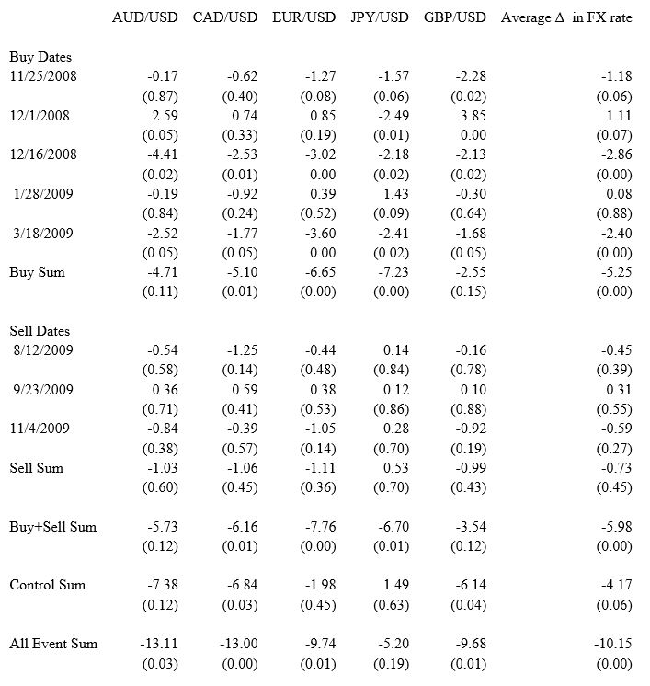

Table 2

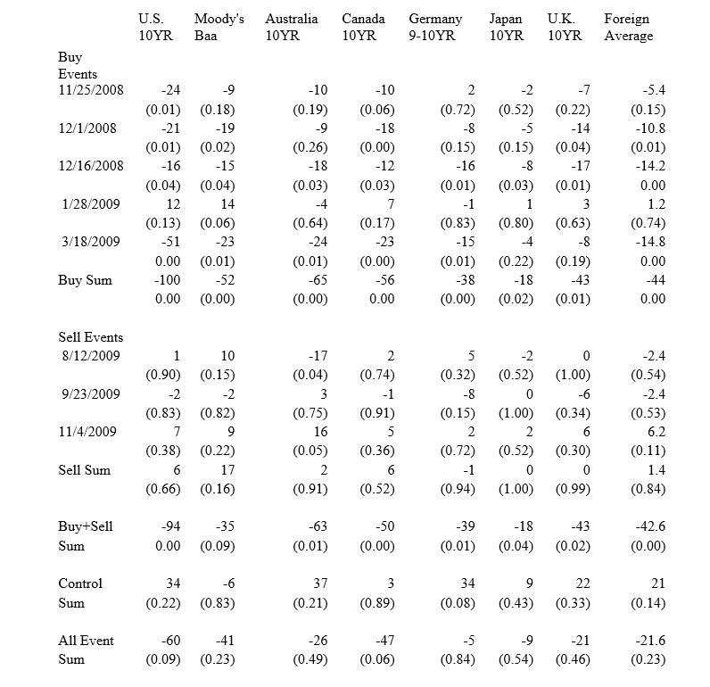

Figure 1

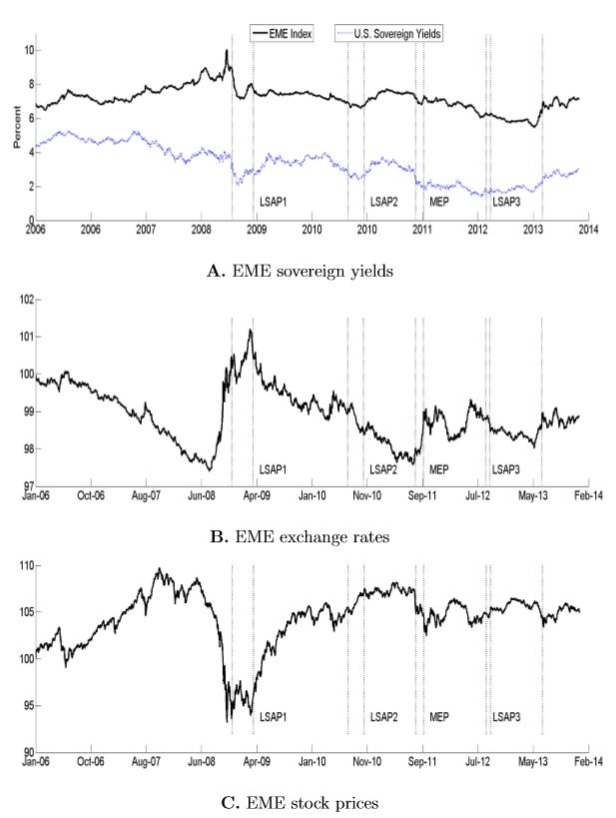

Figure 2

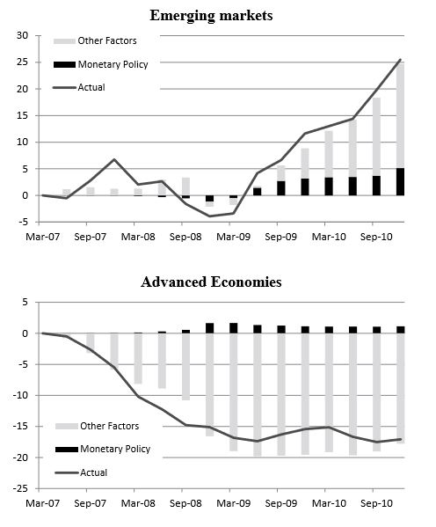

Figure 3

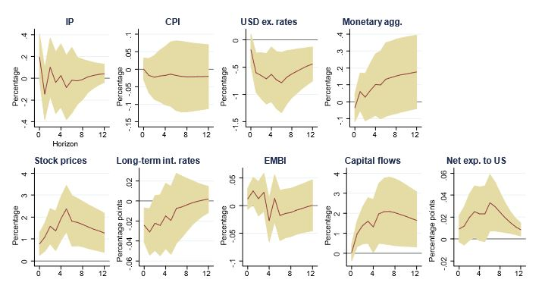

Figure 4

